Guidance on the Diagnosis and Management of Osteoporosis in New Zealand
Osteoporosis New Zealand (ONZ) has published Guidance on the Diagnosis and Management of Osteoporosis in New Zealand. There follows a summary of why the guidance was needed, how it was developed and what it covers.
Why the guidance was needed
A major effort is currently underway in New Zealand to reduce the incidence of all fragility fractures caused by osteoporosis, and hip fractures in particular. In 2012, ONZ published BoneCare 2020, which called for implementation of a systematic approach as illustrated in figure 1.
Figure 1. BoneCare 2020: A systematic approach to hip fracture care and prevention for New Zealand
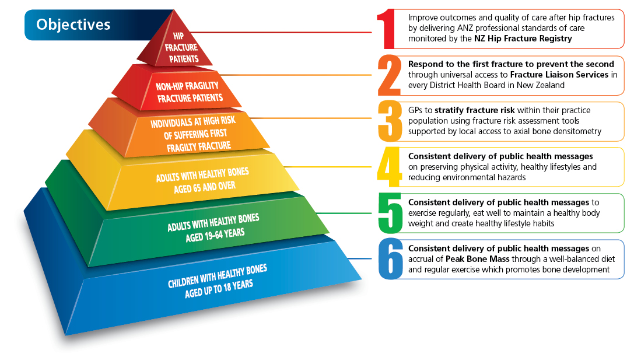The diagnosis and management of osteoporosis relates to the first three objectives of the strategy. Osteoporosis guidance that is specific to New Zealand is currently not available. Accordingly, clinicians rely on clinical guidelines produced for other countries which may result in variation in practice.
How the guidance was developed
In February 2016, ONZ and ACC recognised that a need existed for development of osteoporosis guidance specific to the New Zealand context. ACC provided ONZ with support to establish an Expert Panel comprised of leading clinicians from primary care, secondary care and ACC. The Expert Panel was tasked to develop guidance which would provide clinicians working in both primary care and secondary care settings with a user-friendly and highly practical tool to support evidence-based practice. ONZ provided project management support to assist the Expert Panel wherever possible to develop this guidance. A professional medical writer was also commissioned to support development of the guidance.
In June 2016, a consultation exercise was undertaken on a previous draft of the guidance. The draft was emailed to the Presidents or CEOs of all relevant learned societies in New Zealand, ACC, the Ministry of Health (MoH) and the Health Quality and Safety Commission New Zealand (HQSC). Feedback was then collated and reviewed by the Expert Panel. Where consensus was evident among consultees or individual organisation’s suggestions could clearly improve the clarity, and focus of the guidance, changes were made to the original draft. The final document was then designed and sent to the organisations to consider granting their endorsement of the guidance.
What the guidance covers
The guidance is presented as an algorithm which distils current evidence for sequential steps in the diagnosis and management process:
- Presentation:
  - For individuals who have sustained a fracture not involving major trauma
  - For individuals with no fracture history and at least one other risk factor
- Lifestyle modifications:
  - Address modifiable risk factors
  - Falls risk assessment and prevention programme if appropriate
  - Vitamin D supplementation if appropriate
- Clinical risk assessment:
  - Bone mineral density (BMD) assessment if appropriate/available (i.e. Dual-energy X-ray absorptiometry [DXA])
  - Fracture risk assessment (FRAX®/Garvan ± DXA)
  - Consider lateral DXA of the spine or spinal x-ray to identify vertebral fracture
  - Exclude secondary osteoporosis in individuals with low BMD for age (i.e. Z-score <-2)
- Risk stratification:
  - Individuals with a 10-year FRAX®/Garvan hip fracture risk ≥3% or a T-score ≤-2.5 are recommended to receive specific osteoporosis treatment
- First-line therapy includes oral bisphosphonates or intravenous zoledronic acid
- Monitoring is based upon measurement of serum procollagen type I N-terminal propeptide (PINP) at 6-months post-treatment
- Response to therapy and post-treatment fracture experience determines the need for second-line therapy or specialist review
The guidance was endorsed by fourteen learned organisations.
The guidance can be accessed online at:
http://osteoporosis.org.nz/resources/health-professionals/clinical-guidance/

